**Project Design Phase-II**

**Technology Stack (Architecture & Stack)**

| Date | 03 October 2022 |
| --- | --- |
| Team ID | PNT2022TMID52021 |
| Project Name | Personal Assistance for Seniors who are Self Reliant |
| Maximum Marks | 4 Marks |

**Technical Architecture:**

The Deliverable shall include the architectural diagram as below and the information as per the table1 & table 2

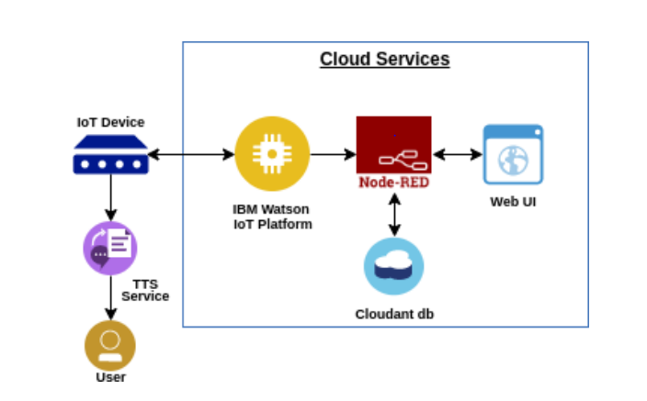

**Table-1 : Components & Technologies:**

| **S.No** | **Component** | **Description** | **Technology** |
| --- | --- | --- | --- |
|  | User Interface | Mobile App | MIT |
|  | Application Logic-1 | Collecting information about medications and checking the timings | Python |
|  | Application Logic-2 | Alarms | IBM Watson |
|  | Cloud Database | Database Service on Cloud | IBM Cloudant DB |

**Table-2: Application Characteristics:**

| **S.No** | **Characteristics** | **Description** | **Technology** |
| --- | --- | --- | --- |
|  | Open-Source Frameworks | Configuration for mobile application development, programming the IoT device , text-to-speech services, and storing details in cloud | MIT,IBM Watson,node red,IBM cloud |
|  | Security Implementations | Encryption implementation for security | SHA-256 |
|  | Scalable Architecture | The application can load as many members as there are logged in. | MIT,IBM Watson |
|  | Availability | Application is available 24/7 | MIT,IBM Watson,node red,IBM cloud |
|  | Performance | Reminds the users at the right time | IBM Watson,IBM IoT Platform |